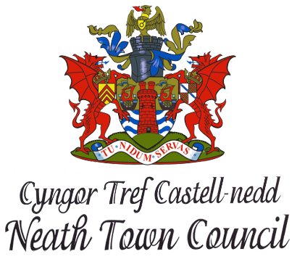

Grant Aid Application
2022/23

March 2022
Introduction to Policy
A grant is any payment made by the Council to be used by an organisation for a specific purpose that will benefit the community, or residents of the community, and which is not directly controlled or administered by the Council. The Council awards grants, at its discretion to, within the Neath Town Council area, organisations which can demonstrate a clear need for financial support to benefit the community by:
- Providing a service
- Enhancing the quality of life
- Improving the environment
- Promoting the community of Neath in a positive way
Grant Application Process
The Grant Aid application process opens and forms will be available and released from 1st April 2022. The closing date for all applications will be 30th September 2022.
The Clerk will receive all applications in the first instance which will then be reviewed at a future Finance Committee meeting.
Applicants will be required to complete an application form. All questions on the application form should be fully answered and additional appropriate information, which supports an application, should be provided.
In addition to the application form organisations will be required to provide the following supporting information:
- a copy of their written constitution or details of their aims and purpose,
- full details of the project or activity,
- demonstration that the grant will be of benefit to the local community within the Town Council wards, the proportion or number of beneficiaries living in the electoral area,
- demonstration of a clear need for the funding,
Grant Aid Applications will be reviewed in the October Finance Committee meeting with recommendations of payments made to the November Full Council meeting.
The Council will make the decision on which grants to award. All applicants will be contacted following the Council's decision.
As highlighted above, a Grant Aid/Community Presentation evening for all local organisations and beneficiaries will be arranged for January 2023.
Conditions of Funding
The organisation must be either non-profit or charitable. Applications will not be considered from private organisations operated as a business to make a profit or surplus.
Grants will not be made to individuals.
Grants will not be made retrospectively.
Applications will not normally be considered from national organisations or local groups with access to funds from national 'umbrella' or 'parent' organisations, unless funds are not available from their national bodies, or the funds available are in adequate for a specified project.
The administration of and accounting for any grant shall be the responsibility of the recipient. All awards must be properly accounted for and evidence of expenditure should be supplied to the Council as requested.
Only one application for a grant will be considered from each organisation in any one financial year.
Ongoing commitments to award grants or subsidies in future years will not be made. A fresh application will be required each year.
Each application will be assessed on its own merits.
The Council may make the award of any grant or subsidy subject to such additional conditions and requirements as it considers appropriate. The Council reserves the right to refuse any grant application which it considers to be inappropriate or against the objectives of the Council.
Any grant must only be used for the purpose for which it was awarded unless the written approval of the Council has been obtained for a change in use of the grant monies, and that any unspent portion of the grant must be returned to the Council by the end of the financial year in which it was awarded.
The Council may make the award of any grant or subsidy as it considers appropriate in the event of any unforeseen urgent event.
Nothing contained herein shall prevent the Council from exercising, at any time, its existing duty or power in respect of providing financial assistance or grants to local or national organisations under the provisions of the Local Government Act 1972, Section 137.
Working for the Community | GRANT AID  Application form for financial year end  1st April 2022 to 31st March 2023
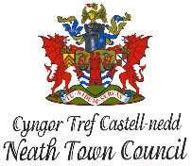
Each year, Neath Town Council makes a limited sum available to help support local community and voluntary organisations. The Council wishes to see such organisations flourish and develop in the Town and the Council’s Grant Aid funding helps to achieve this objective.

The attached notes will help you establish whether your Organisation is eligible to be considered for Grant Aid, and if so, how to apply. They also explain what additional information you need to provide with your application and how any financial assistance given will be paid.

Please read these notes before you complete the enclosed application form and make sure all necessary information is submitted along with your application.

Please print clearly on the application form to make sure it can be easily read.

Alternatively, you may complete an electronic version, details of which are available on request.

All applications received will be acknowledged in writing within 7 days. If you do not receive written confirmation within this time, please contact Sarah Williams (sarah.williams@neathtowncouncil.gov.uk).

Many thanks
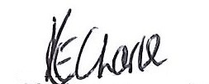

Kathryn Charles
Town Clerk

Working for the Community | Neath Town Council  Grant Aid to Local Organisations
Important notes to help you complete the application form

Eligibility

Grants will not be made:

- to organisations situated outside the area administered by Neath Town Council unless a clear benefit to the inhabitants of the Town can be established. In such cases, supporting information demonstrating the level of benefit must be provided.

- to organisations established for political purposes.

- where the aims and objectives of the organisation are inconsistent with the values of the Town Council.

Additional conditions

- Grants can only be paid for a single year and a second application is not allowed for the same project/purpose.

- Successful applicants will be required to prove to the Town Council within nine months of receiving a grant award, as to how the grant has been used. In addition, successful applicants must confirm receipt of grant assistance on the organisation's letterhead as soon as practicable. Organisations with premises will also be required mention the support given by the Town Council.

Working for the Community | GRANT AID  Application form for the  financial year 1st April 2022 to 31st March 2023
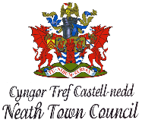
Please read the guidance notes before completing the form. The deadline for returning your application is 30th September 2022. Only applications submitted on this form will be accepted.
Section A: Your Organisation details
Name of Organisation:

(Please note that if you are successful, this will be the name the cheque will be made payable to)
Registered Charity number (If applicable)
Name of Main Contact:
(Person we should address all correspondence to)

Full Postal Address of Organisation:

Contact Telephone Number: | Daytime:  Mobile:
Main Contact Postal Address:
(If different from above address)

Main Contact email address:

Bank details  (This will be used to issue payment only if the application is successful)  Or  Alternatively please stipulate if a cheque will be required. | Name of account:  Name of Bank:  Account No:  Assort Code:  Is this a Business Account? Yes/No  Cheque required Yes/No
Have the organisation received Grant Aid from Neath Town Council in the past?
If yes please give details below:

Date | Amount
 | £
 | £
 | £
Please provide a brief description of the main activities of the organisation and who attends.

Are you a not for profit organisation? □ Yes □ No

How long has the organisation been established?

Section B: Why are you applying for Grant Aid?
Please provide a brief description of what you would use the Grant Aid for?
(Please continue on a separate sheet if required)

How will you do this?

Start Date:

Completion Date:

Section C: Sustainability
Will the project still continue after this funding has ended? YES / NO

If yes, please give an explanation: -

Section D: Completing the application
Your Signature - This must be the signature of the main contact named in section A.

Declaration: -

- I certify that the information contained in this application is correct

- If the information changes in any way, I will inform Neath Town Council

Signed: ____________________________ Date: ___________________

Please note that this form requires two signatures
Second Signature: -

Position held in organisation: _________________________________________

Signed: ____________________________ Date: ___________________

Completed application forms should be returned to: | Neath Town Council  10/12 Orchard Street, Neath, SA11 1DU

Check list:-
- A copy of the organisations Constitution or rules to be provided
- Have two signatories on the form
- Submission of the application form is completed before the deadline date
- You have considered any Equality Impact issues in your application

Please note any applications received after the deadline date will not be considered.
For any further information or assistance in completing the form please contact
Neath Town Council on 01639 642126.

